Designing A Resume / CV Using Canva

1. Introduction

1.1 Overview

A resume is a document commonly used in the hiring process. It includes information about your background and qualifications and should communicate the most important, relevant information about you to employers in a clear, easy-to-read format. The goal is to quickly communicate why you are uniquely qualified for the position based on your skills and experience.

1.2 Purpose

Resumes tell the employer about your experiences, skills and work history. Use your resume to highlight items that indicate you are a good worker, are qualified for the position and bring desirable skills to the job.

2. Problem Definition and Design Thinking

2.1 Empathy Map

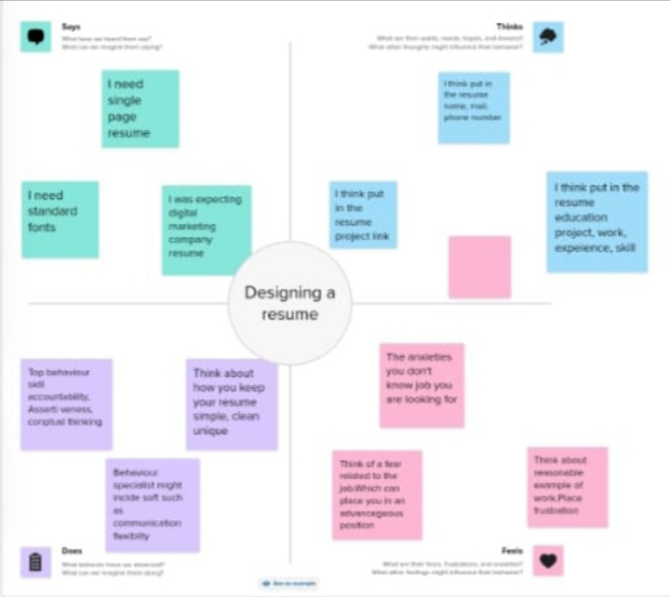

2.2 Ideation & Brainstorming Map

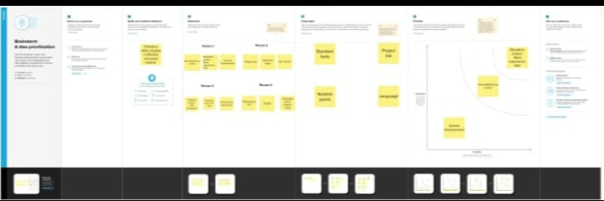

3. Result

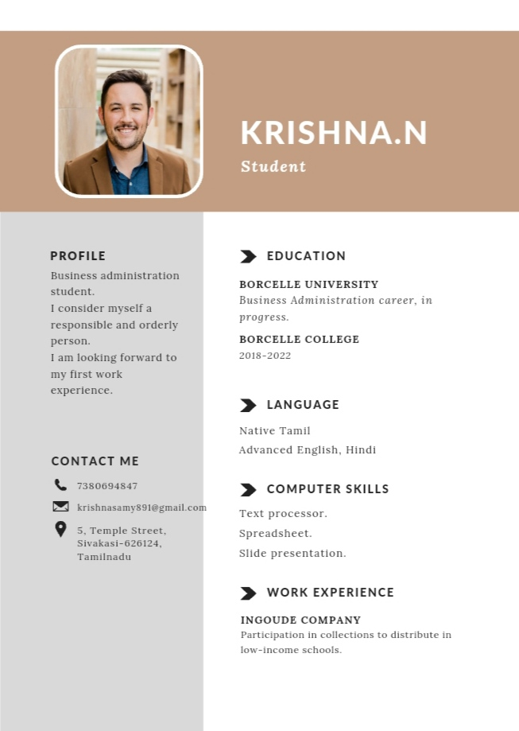

4. Advantages & Disadvantages

4.1 Advantages

\* Your abilities, experiences, and accomplishments can be highlighted in a well-written resume, which can attract the attention of potential employers and improve your chances of getting hired.

\* Employers will spend less time and effort sorting through multiple resumes if a resume is clear and concise.

\* As a result, they may be more likely to consider you for an interview and spend more time reviewing your application.

\* An effective resume highlights your skills, experience, and accomplishments.

4.2 Disadvantages

\* A job resume is a document where space is premium.

\* The resume should be interesting enough to urge the employer to call you for a one-on-one interview.

\* The fresh graduates from college often find themselves struggling in building a fresher resume.

5. Application

A resume is a summary of your education, job experience, and job related skills that you send to potential employers. From it and the accompanying application letter, potential employers learn about you and decide whether to interview you for a job.

6. Conclusion

I look forward to any opportunity to discuss the position and I can do for your company. I believe my vision and values align with the (company) brand and that I’d be an excellent fit for your organization.

7. Future scope

\* Employers will prioritize soft skills like communication, creativity, and emotional intelligence over heavy technical skills.

\* The use of video resumes will increase, and building a personal brand through social media and personal websites will be essential.